# TESTS RESULST

## COMPONENT TESTS

Saturation of inductor;

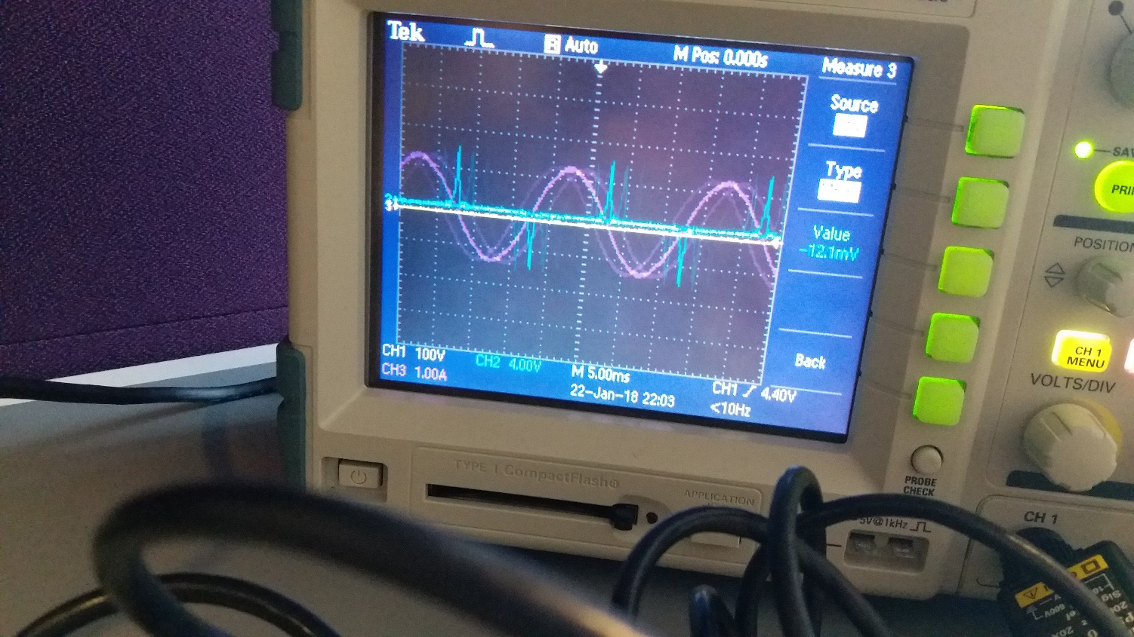

Figure 1.Saturation of Inductor Experimental Result

Measurement of inductance;

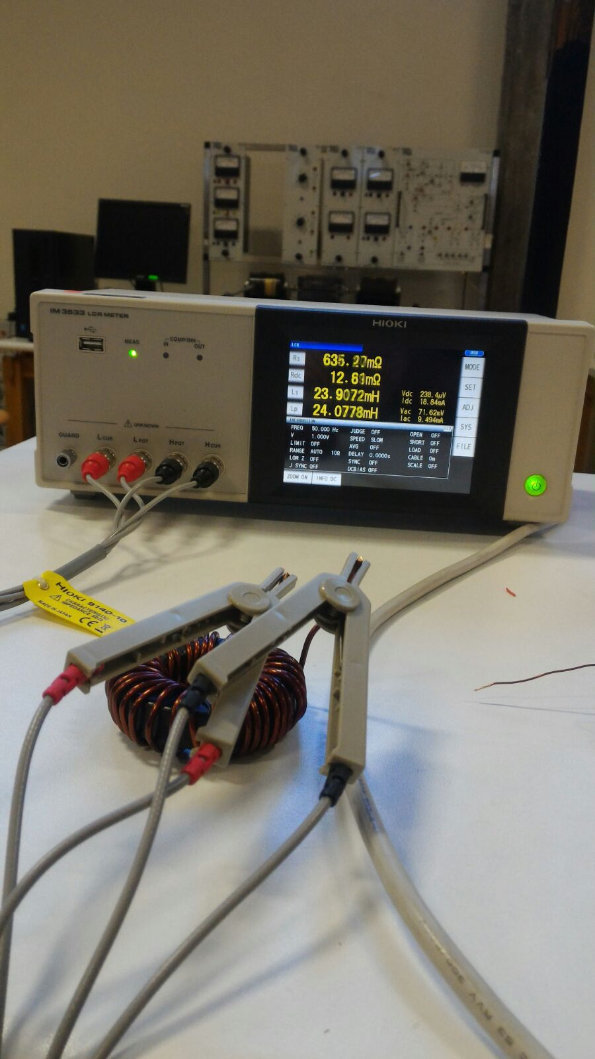

Figure 2.Inductance of Component is used in Buck Converter

## TLP250 Tests (Duty Cycle and PWM)

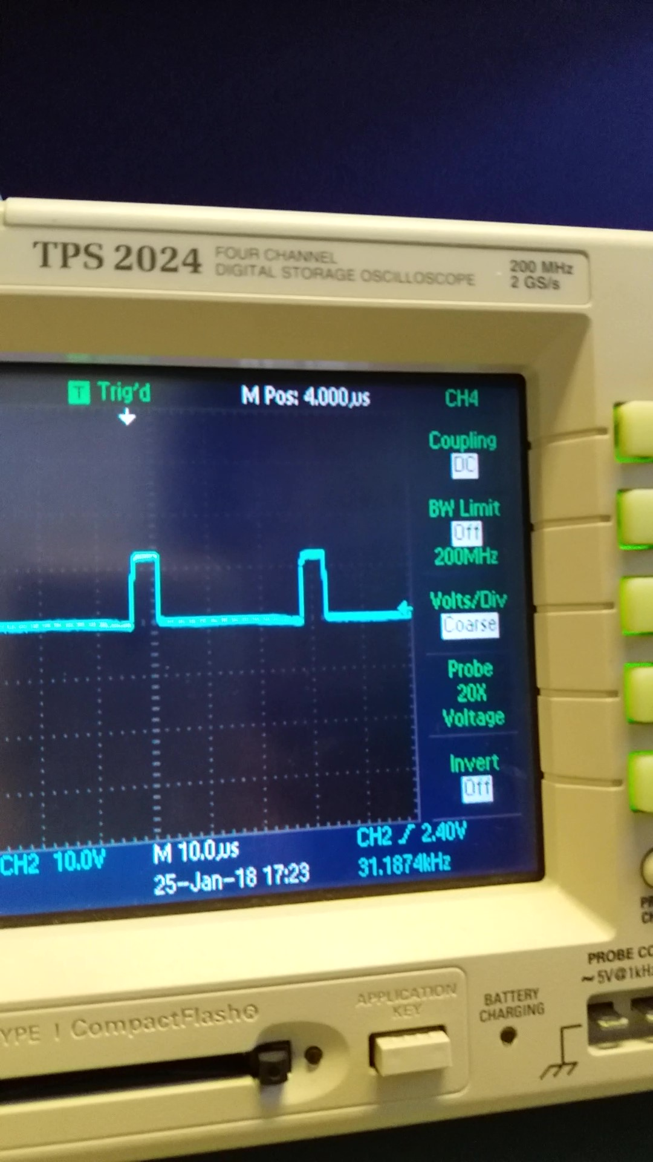

Figure 3.Output of TLP250 Duty Cycle at %15

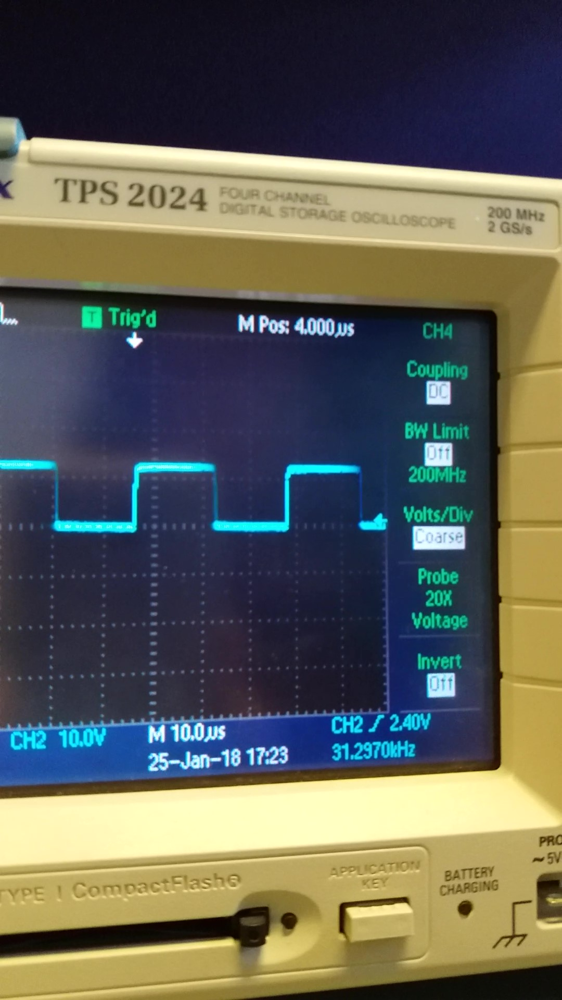

Figure 4.Output Waveform of TLP250 Duty Cycle at %50

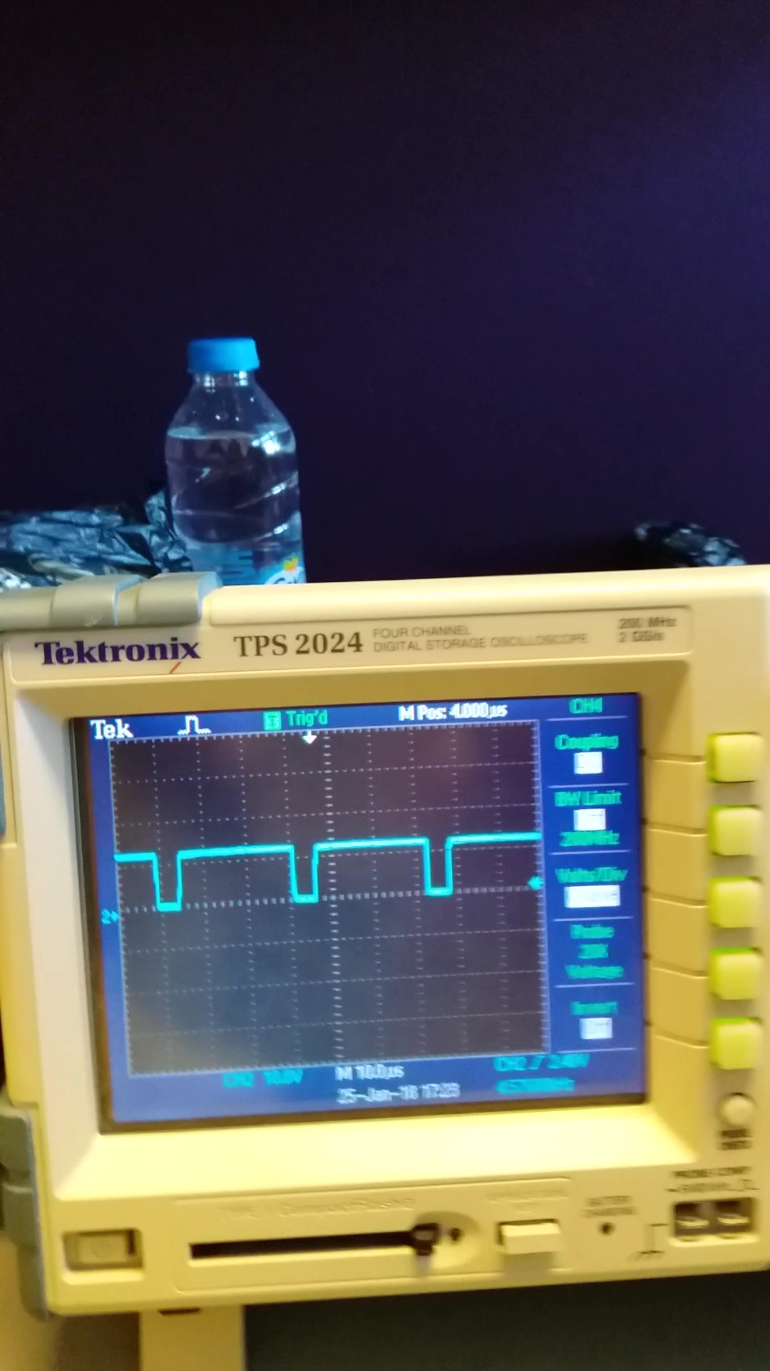

Figure 5.Output Waveform of TLP250 Duty Cycle at %90

## R Load Tests

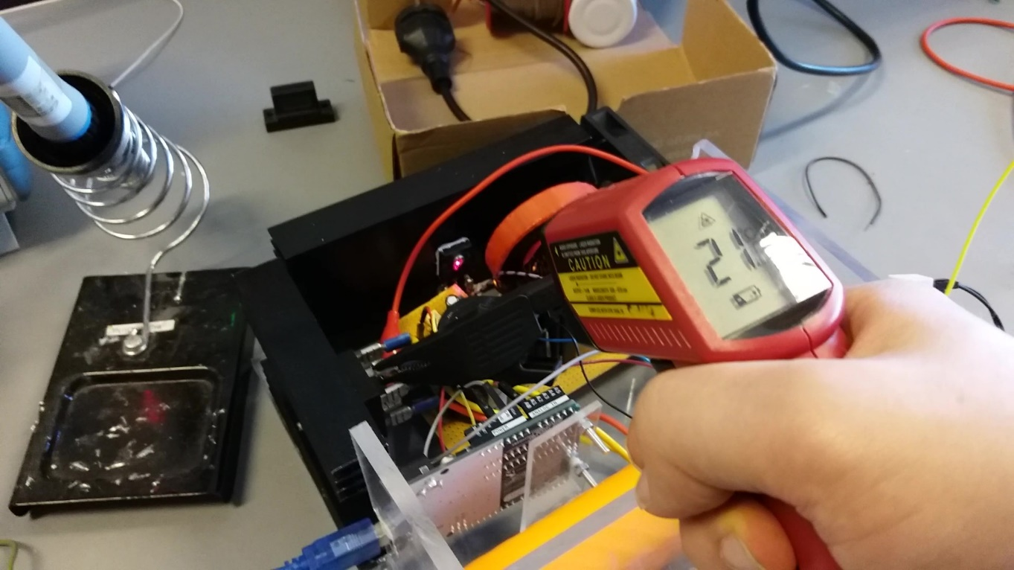

Figure 6.Degree of MOSFET after 5 minutes

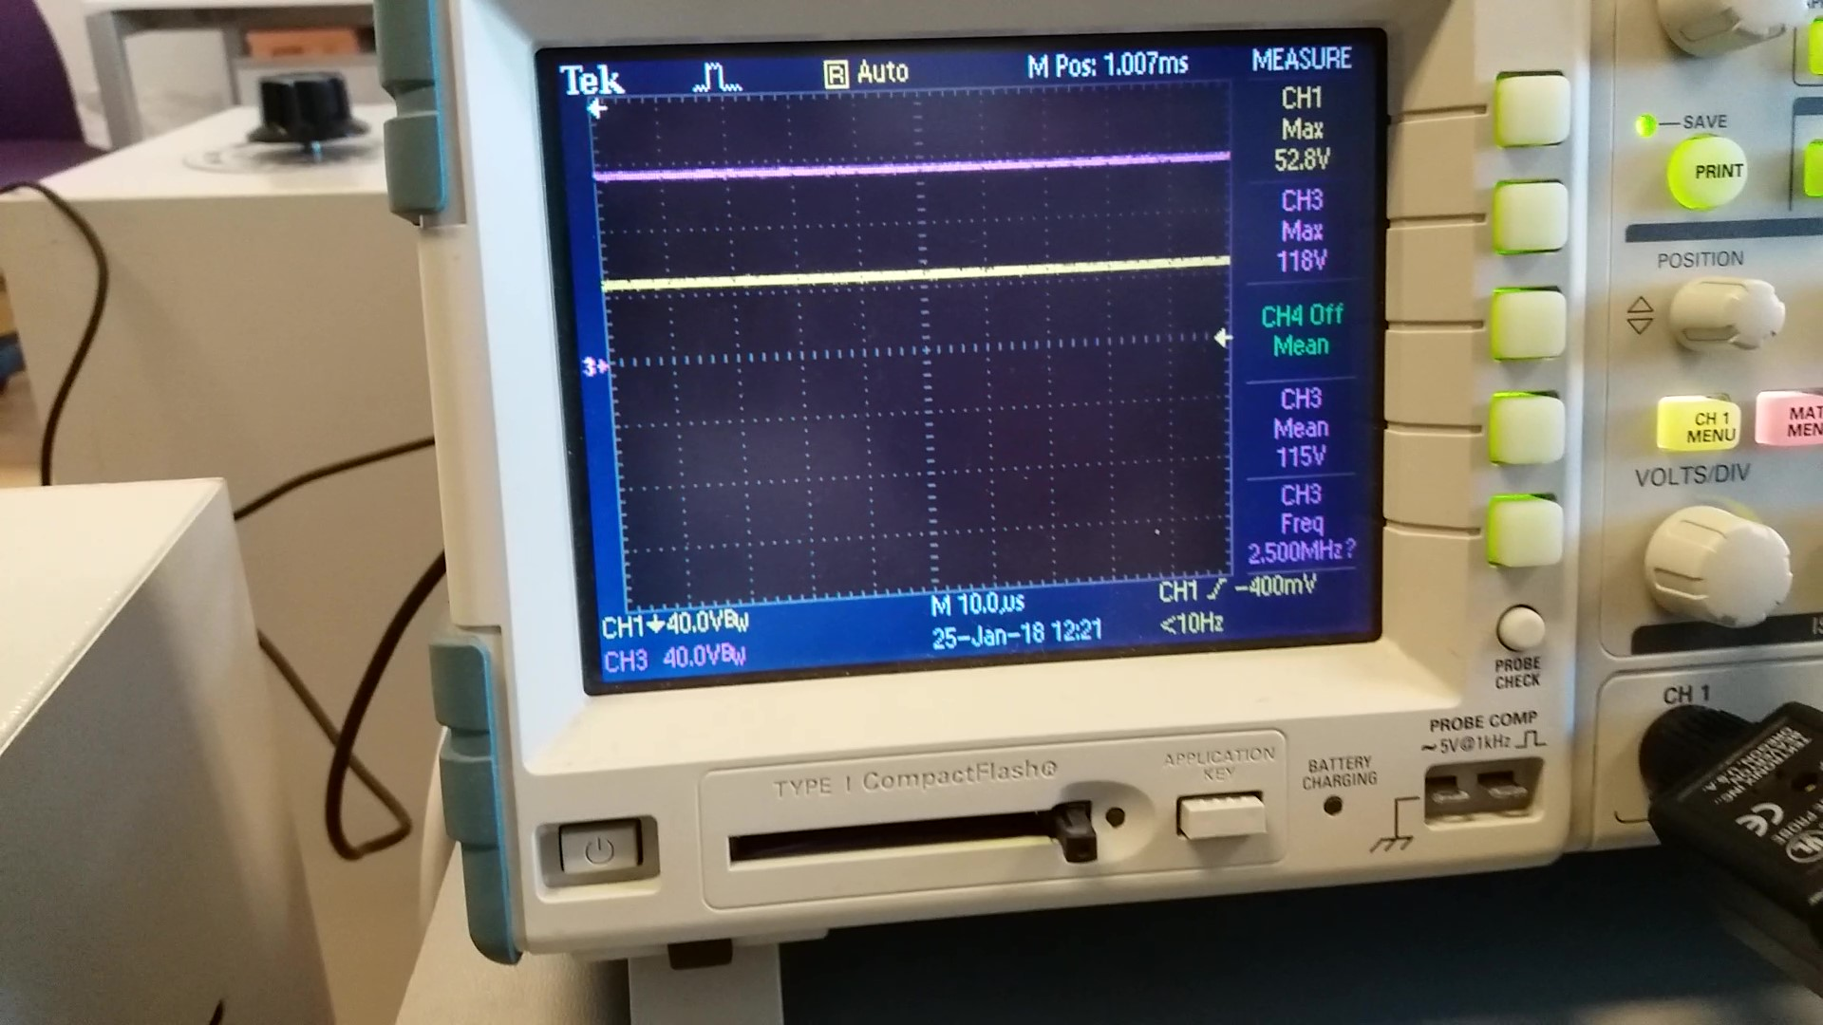

Figure 7. R-load Output Voltage and Rectifier Output Voltage at %30 Duty Cycle

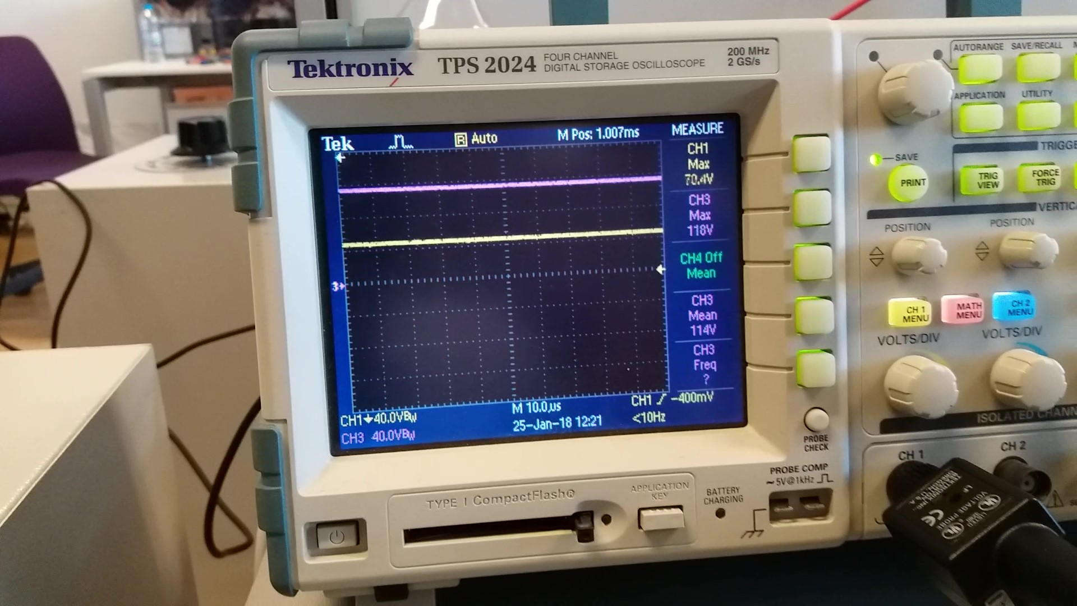

Figure 8 R-load Output Voltage and Rectifier Output Voltage at %60 Duty Cycle

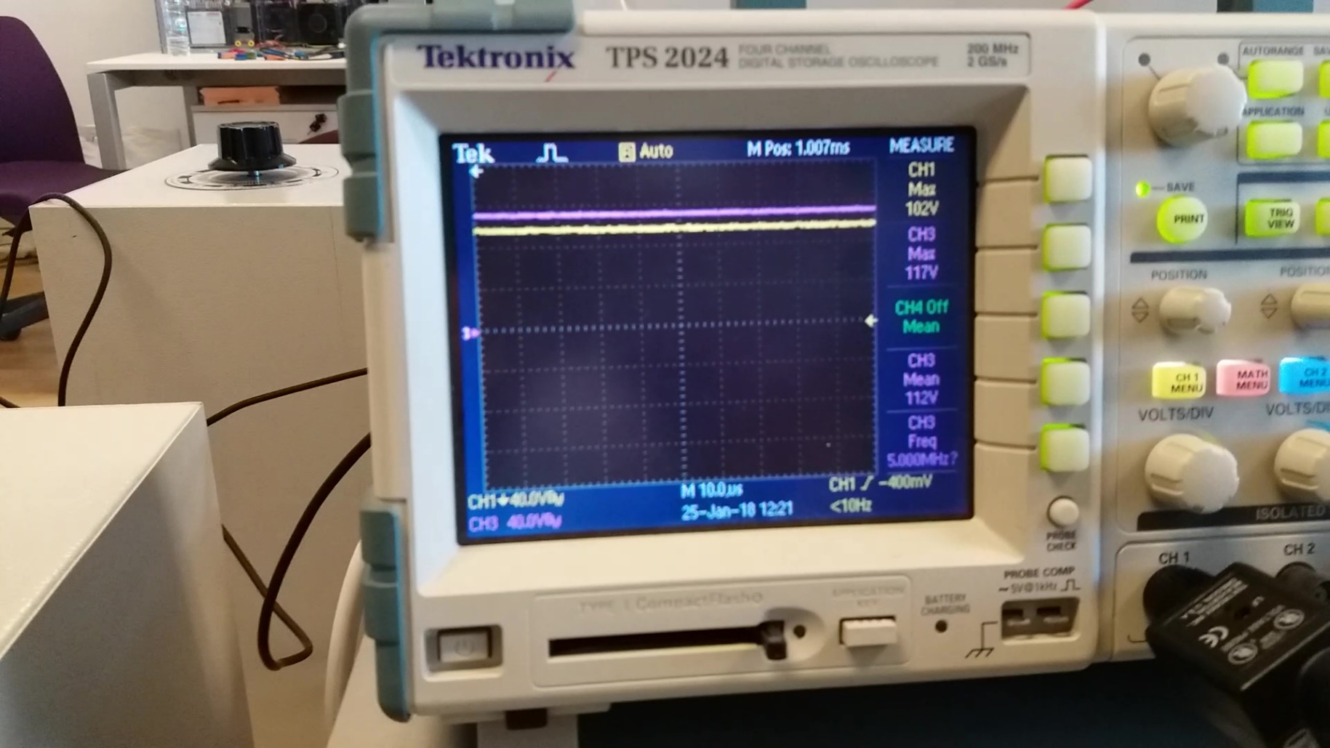

Figure 9 R-load Output Voltage and Rectifier Output Voltage at %90 Duty Cycle

## Motor Tests

## 

Figure 10. Degree of MOSFET after 5 minutes (Motor at 220 V)

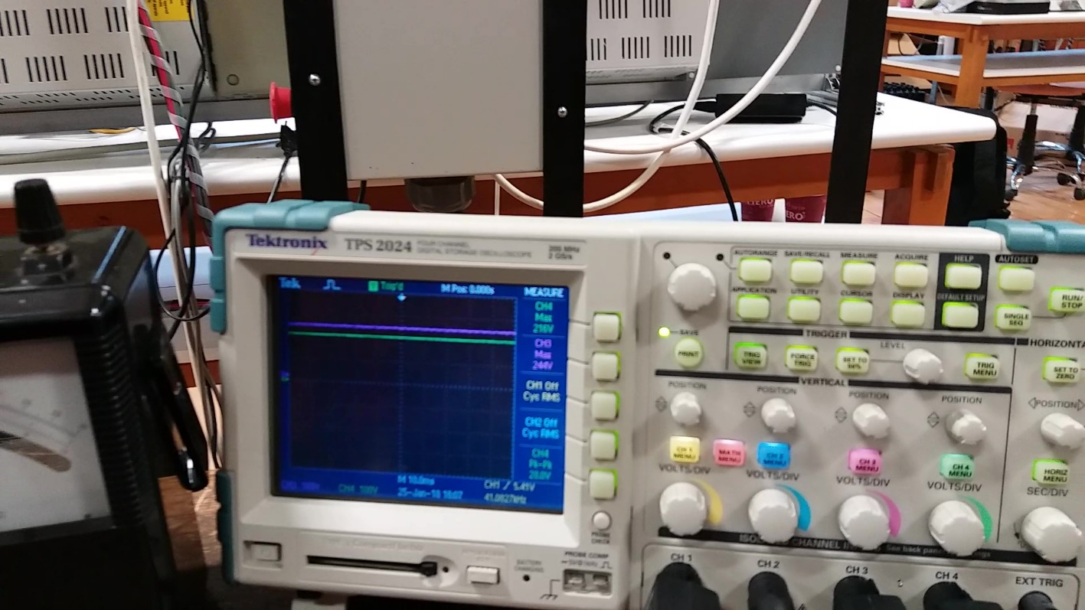

Figure 11.Connecting Motor Mode Output Voltage and Rectifier Output Voltage at %90 Duty Cycle

## 

Figure 12.Connecting Motor Mode Output Voltage and Rectifier Output Voltage at %60 Duty Cycle

## 

Figure 13.Connecting Motor Mode Output Voltage and Rectifier Output Voltage at %30 Duty Cycle

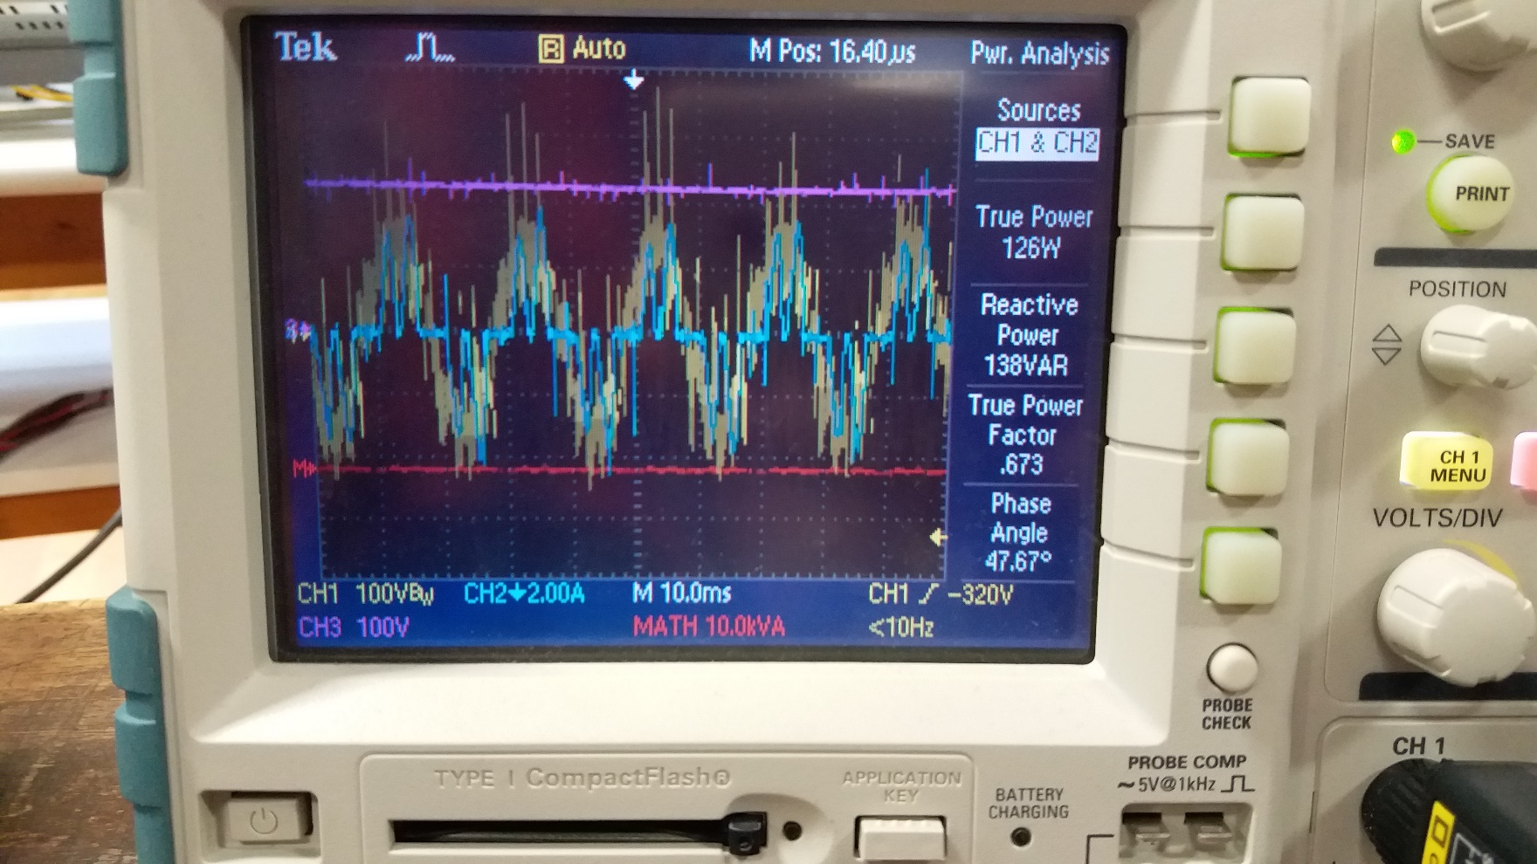

Figure 14.Input Power of System

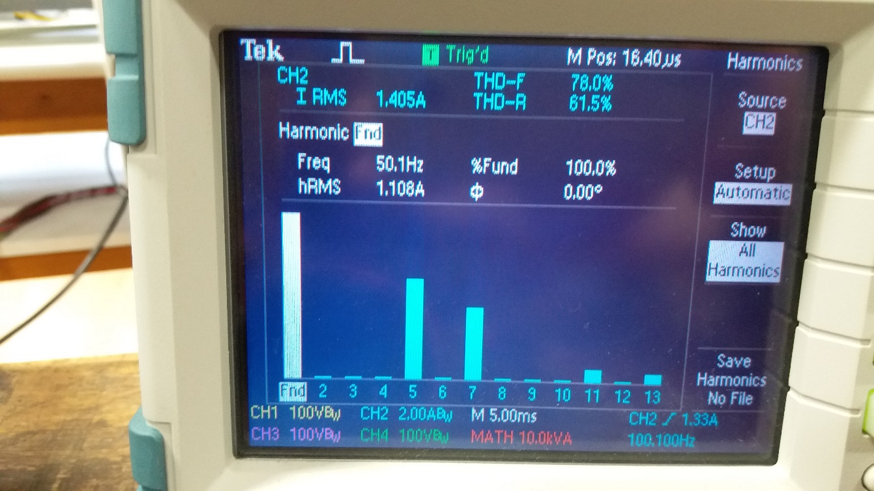

Figure 15.THD of Input Current

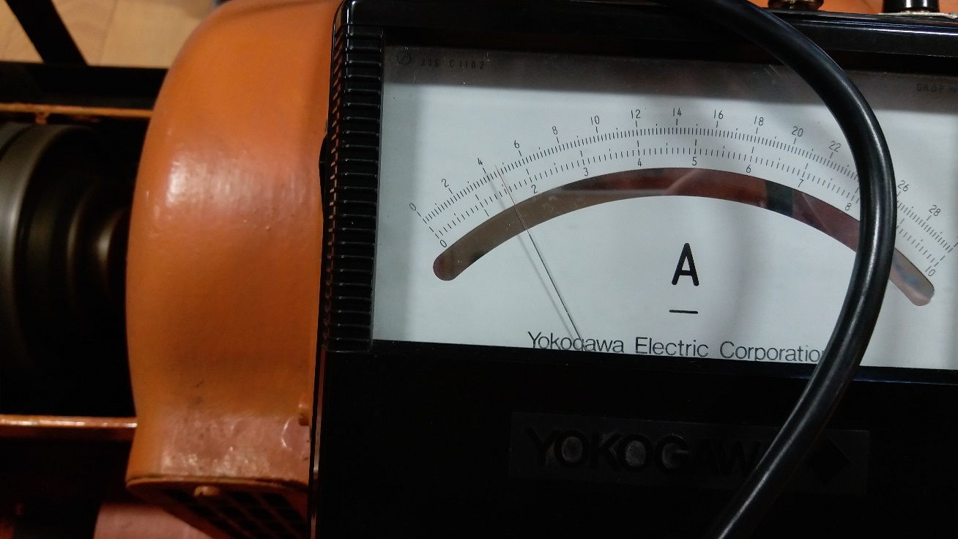

Figure 16.Output Current of System When Output Voltage is 220V

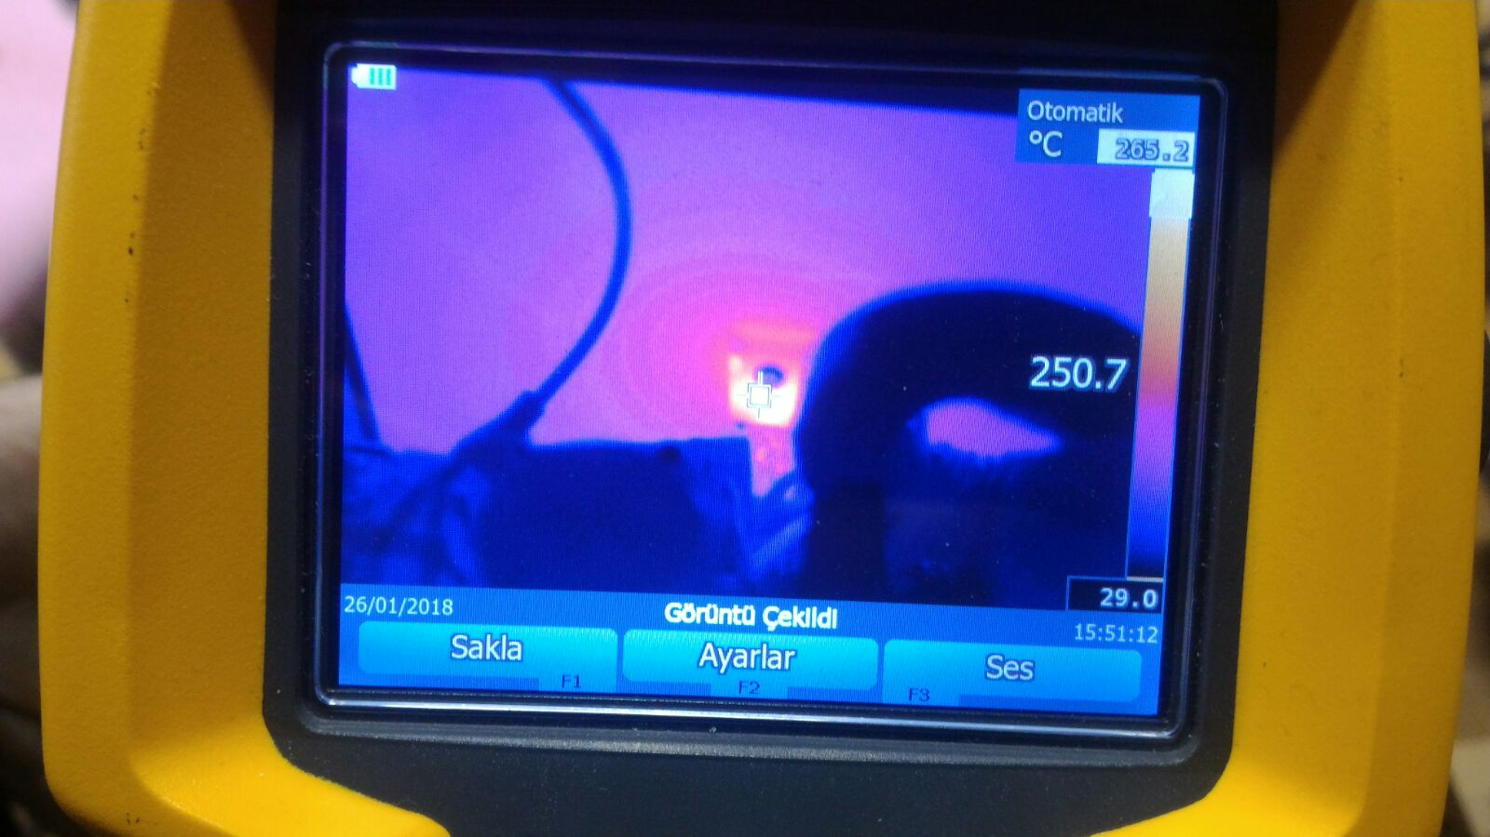

Figure 17. Full Load Degree After 30 Seconds